Traditional Memory – Spanish
Sample front and back side of the cards:
una manzana | 
un plátano
un tomate | 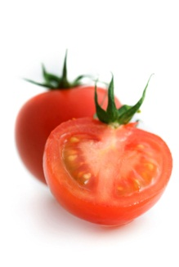
una sandía | 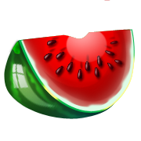
un arándano

